# INTRODUCTION

This data visualization project explores the Washington state housing market through an interactive Tableau dashboard. The objective is to gain insights into factors influencing house sale prices across the state. Utilizing a dataset containing house sales information for Washington, the project analyzes details like price, square footage, number of bedrooms and bathrooms, and property characteristics. The interactive dashboard allows users to explore trends and patterns in the data across various facets.

Dataset Name: House sales Dataset

Dataset Reference Link: <https://1drv.ms/x/s!Aq7N_1DshPXkhn93KXSJixd_OiI3?e=StybfD>

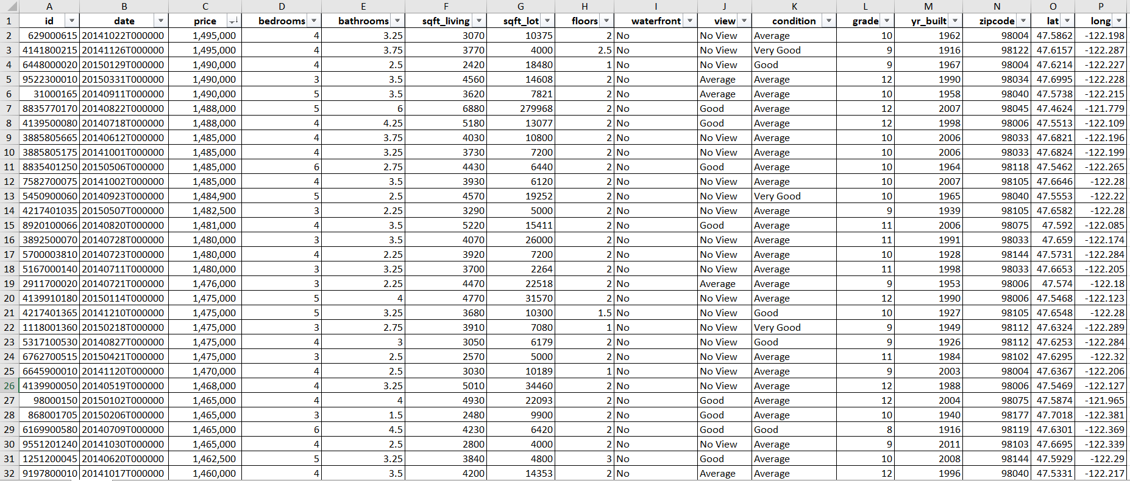

# **PROCEDURE**

* Upload the data to tableau

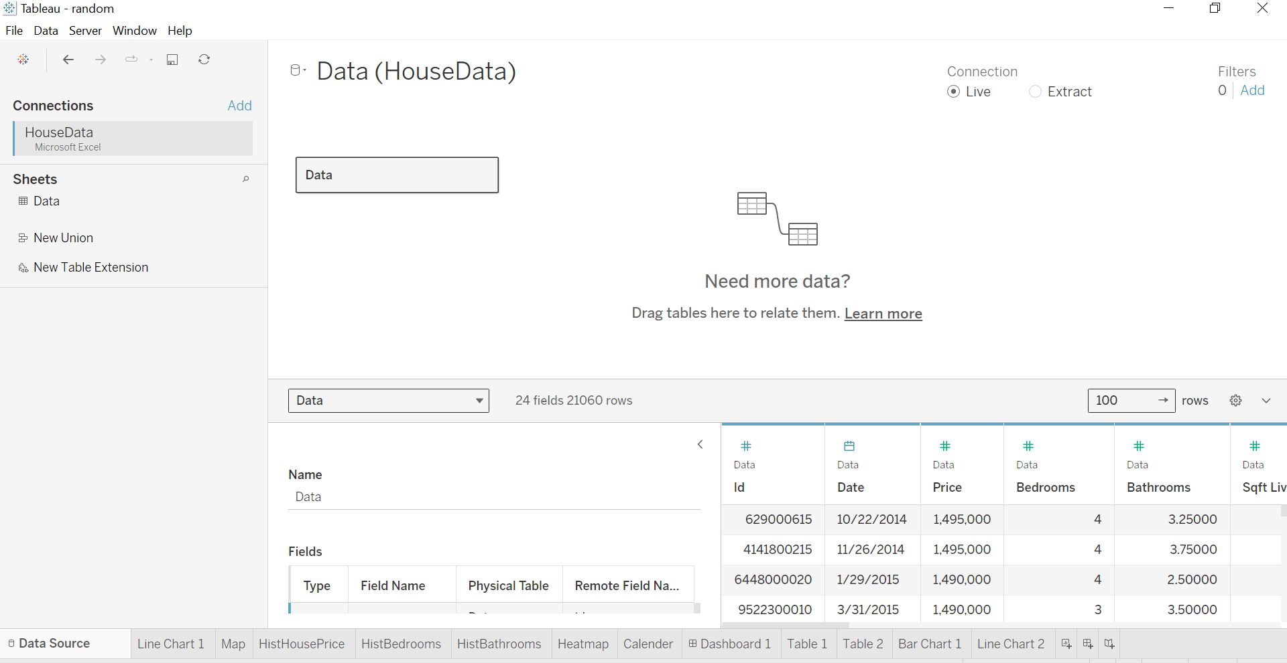

* Questions and output

1. Analyze the trend of the daily house sales price.

1. What is the average price of houses in every area from our housing price dataset?

1. How are house prices distributed across different price brackets?.

1. Evaluate the distribution frequency of bedrooms and bathrooms

1. Create a view vs condition heatmap for the average price of each house.

1. Build an automatic calendar based on days and dates.

1. At what point in a house's lifespan does its price tend to be the lowest?

* **DASHBOARD**

# **CONCLUSION**

The dashboard serve as a powerful tool for presenting our analysis and insights effectively, enabling stakeholders to gain a deeper understanding of the house pricing dataset and make informed decisions based on the findings.